Assignment # 4 (For BS-CS: Sections C & N)
(CS-3001 Computer Networks – Fall-2022)

Due Date and Time: Tuesday, 6th December, 2022 (02:25 pm) Marks: 10

Instructions:
- Late assignment will not be accepted
- Only handwritten attempt will be graded, i.e., printed attempts will not be graded
- Only the attempts submitted to Mr. Fahad or Mr. Amir in the Academic office (till the due date & time) will be considered, i.e., the submissions that will be slided beneath instructors’ office doors or submitted elsewhere will not be graded.
- There will be no credit if the given requirements are changed
- Your solution will be evaluated in comparison with the best solution
- Whenever a calculation is involved, your solution should show complete steps and a final answer. There will be significant marks for the correct final answer (as far as assignments are concerned).
- You must write your roll number, name, and section (CNet Course section) on your submitted attempt.

For the problems below, consider your roll number = y. For example, if your roll number is 16i-0125, then y = 125

Problem 1: [5 Marks]
Consider the following network. With the indicated link costs, use Dijkstra’s shortest-path algorithm to compute the shortest path from x to all network nodes. Show how the algorithm works by computing a table similar to Table 5.1 (of the text book; 8th Edition). Show all steps.

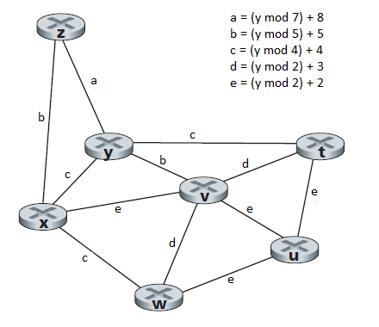
Problem 2: [5 Marks]
Consider the network shown below, and assume that each node initially knows the costs to each of its neighbors. Consider the distance-vector algorithm and show the distance table entries at node z. Show all steps.

